Week 3

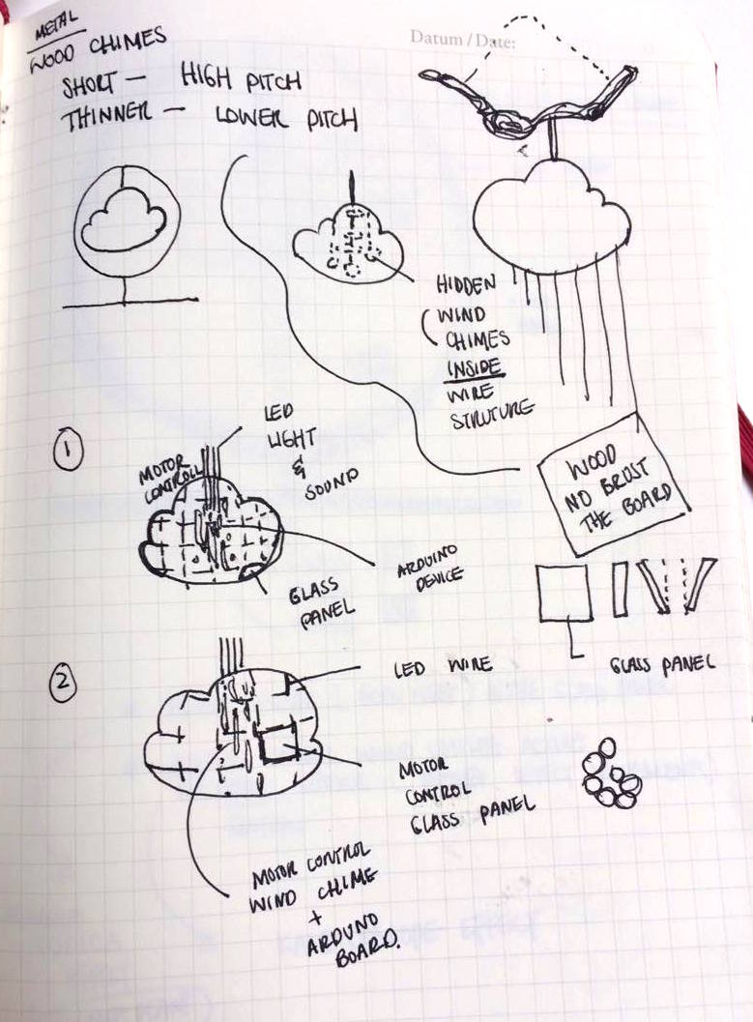
Week 2 was very research based, start from own personal experiences as I looked into loneliness among in everybody, from the relationship between parent and kids from young age to big city living working class age between 16 to 34, then to the almost forgotten older generation, how they deal with loneliness. As I go further down on this research journey I realised being lonely can have a serious effect on your physical and metal well-being. At the end of the week I have came to realise how big of an issue I'm looking at, I felt using a light hearted and playful method to engage with this issue would be the most suitable. I empathized with the young working class age 16-34 year olds, they are often being overlooked, especially working in a long hour, high stress level and tech-driven big city can make people feel very socially and mentally disconnected and feel lonely. I created persona Jessica Day, 24 years old graphic designer with high demand working hours in the cit of London, UK. Use Jessica I created scenario to help me develop my concept.

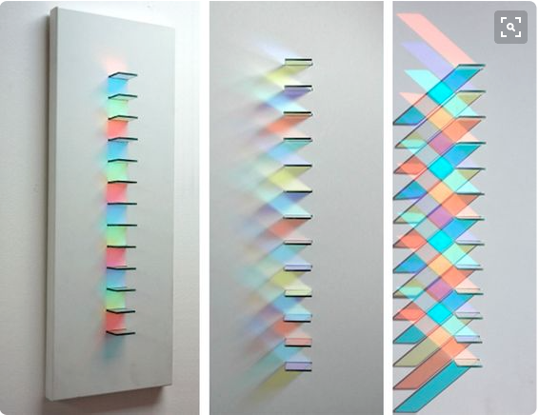
This week, first as a interior environmental design background student I immediately looked into the interior aspects of the issue, my target audiences is busy working class, the time they will spend in their house will be night time and weekends, as they will spend most days in the office. Nights are dark, imagine come home to a dark, cold and empty apartment after a long day of work, epically if you have family friends far away this will easily cause you to feel lonely. The colours of the interior can instantly transform the space massively, adopt this theory with childhood toy kaleidoscope and inspired by light artist Chris Wood, I created a interactive playful message unit - Cloud Chime, use the factor of Change through colour, reflection and sound to playfully interact with loved ones globally in a home.

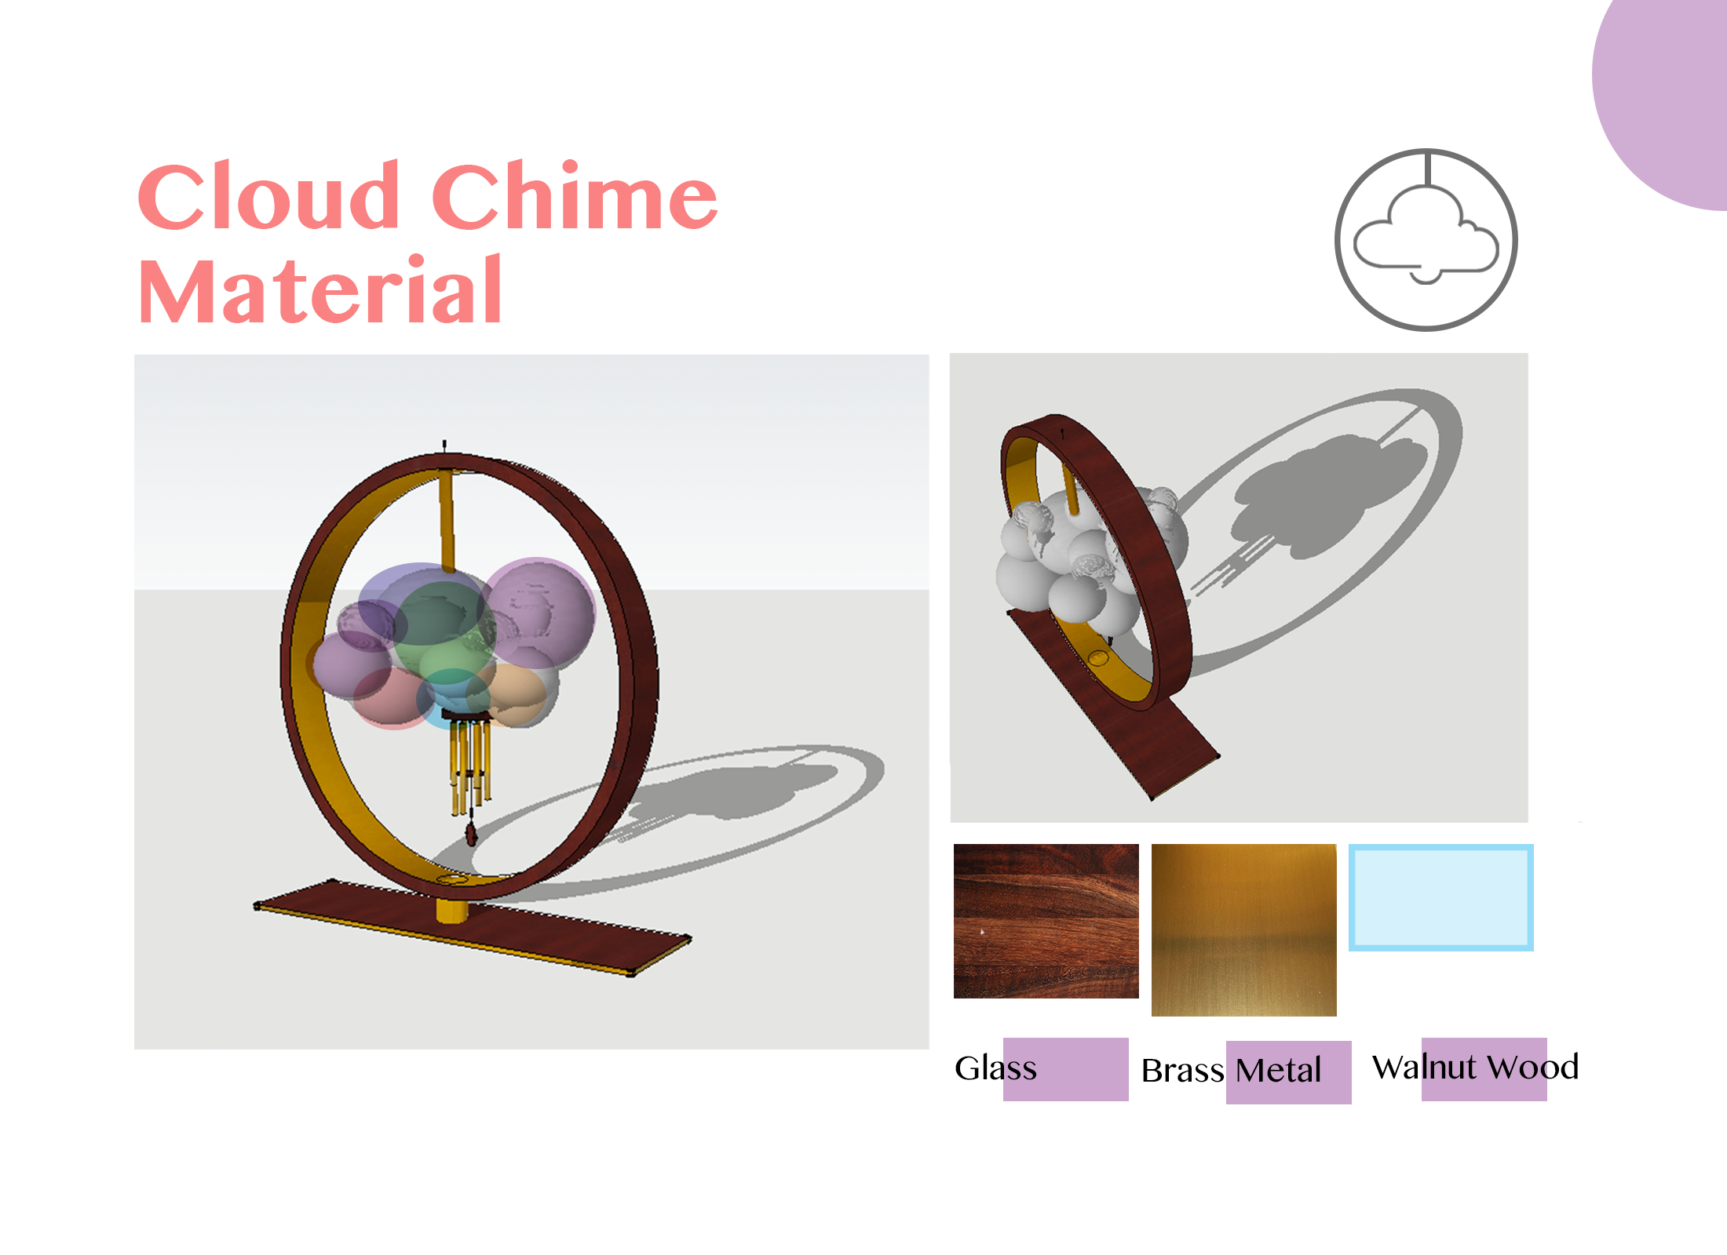
Shaped like a cloud which represent home, comfort and now days online storage. Wire framed structure laced with LED light and fitted glass panels and wind chime, all motor controlled by touch sensor hanging from the outer circle frame, which inspired by Zen philosophy. Fitted glass panels move into different angles with changeable LED light, create reflections mimic a almost kaleidoscope effect in memory of a fun activity as a child. The wind chime will create “natural” crispy sound effect controlled by motor. Every touch made by users will change the angel of the glass panels and order of LED create Change, a small playful way to interact with loved ones to feel emotionally and socially connected. Main concept of invisible technology, break away from smart interface with sculptural and playful exterior and embedded technology “hidden” inside. Make it easy access to all age groups and any technology knowledge background. The user's experiences and content therefore become the most important part in this product.
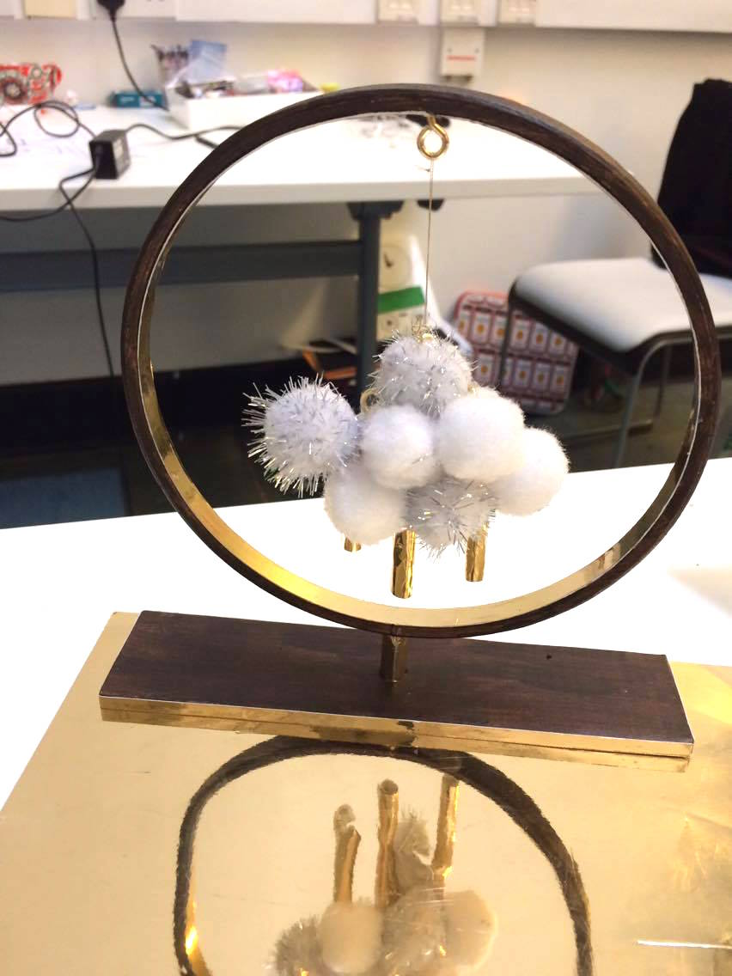

This week followed by generate a lot of contextual images which work with my strength of computer software knowledge and drawing ability to create 3D model of the concept, material prototype on Sketch up and produce sketches of concept prototypes and logo. Also build a small 3D prototype real life model and explore the possible solution of making the find prototype in real scale and mimic the function and form in short amount of time – Week Four. Final week four, will be concentrate the most on the making of the final experienced prototype and 1min video.

